December Newsletter
ARMA Int’l Lou Chapter

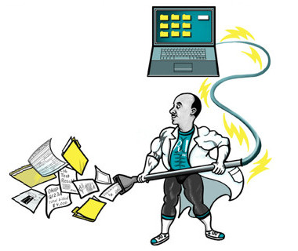
Upcoming Meetings
January 15, 2019
February 19, 2019
March 19, 2019 - meeting with the Lexington Chapter

Quote of the Month

We are made to persist…that’s how we find out who we are.
Tobias Wolff

http://louisville.arma.org/
John Spencer, RIM Service Delivery Manager at Ernst & Young, offered 6 ways information professionals can increase their self-awareness:
- Be intentional | Plan your actions.
- Learn the truth about yourself | Ask colleagues, “What’s one thing I could do better?”
- Examine your personal filter | Ask yourself, “Why did I say that?”
- Pay attention to how your behavior and body language impacts others | Do others usually smile at you? Avoid you?
- Find “loving critics” | Go with the ones who give the most honest answer to that “what could I do better” question.
- Practice self-evaluation and reflection | When something goes well, or poorly, get to the “why.”

Do you have an idea for a meeting topic??? Email a member of the Board – we would love to hear from you!!

Meet your Board Members -
Andy Dobelstein, President,
adobelstein@thedatavault.com
Missy O’Brien, Vice President,
missy.obrien@louisvilleky.gov
Yvonne Wathen, Treasurer,
yvonne.wathen@pcusa.org
Lydia McGahee, Secretary,
lydia.mcgahee@texasroadhouse.com
Matt McMahan, At Large,
matt.mcmahan@texasroadhouse.com
Angela Fleig, At Large,
amfleig@gmail.com

The More you Know…
ARMA's Countdown to 2019 Savings
Check the ARMA.org site daily for discounts on resources!!

It's One of Our Most Popular Offerings! Mark Your Calendars Now!

The ARMA Virtual Conference is free to all Professional and Associate members!

Back by popular demand, the ARMA Live! 2018 Virtual Conference will feature four of the top education sessions, as evaluated by conference participants, and a virtual exhibition hall.

For more details and to register, visit the
virtual conference web page.

Connect with your Community-
Facebook
ARMA
New website coming soon!

Today’s Presentation –

Tech Update, Gadgets and Toys
Bob is the owner of Daugherty Technology Consulting. Bob has spent his 30 plus years in the technology industry focusing on CPA firms and the technology required to run them effectively. Bob has multiple technical certifications as well as degrees in accounting and computer technology and regularly speaks to local professional associations on a variety of technical topics. Daugherty Technology Consulting focuses on the technical needs of small to midsize firms to give them the technical advantages as large firms that have inhouse technical staff.
Bob will present technical topics everyone should be paying attention to, including security, AI, moving everything to the cloud, the latest in equipment and a fun look at some tech toys and gadgets.

